Expt No:  07 | BOTTLE FILLING SYSTEM
Date:
/ /2025

- AIM:
To design a ladder logic program to perform Bottle Filling System.

- APPARATUS REQUIRED:

- Bottle Filling System.
- PLC Trainer Kit.
- Personal Computer [PC].
- VersaPro Software Installed.
- RS - 232 cable.
- Patch Chords.

- PROCEDURE:

- Load the Versapro Software to the PC.
- Open the Versapro Software.
- Switch ON the PLC Trainer and Bottle Filling System.
- Connect PLC and Bottle Filling System kit.
- Open the New folder and draw the ladder logic program.
- Connect the PLC to PC.
- Select the correct hardware Configuration [Sl. No].
- Store the Program to PLC.
- Run the Program.
- Verify the performance of the Bottle Filling System.

- PROGRAM FOR BOTTLE FILLING SYSTEM:

I1 = Input from proximity (Capacitive Pickup) sensor - Bottle indicator.
I2 = Input from position sensor.
I3 = Input from low level sensor in process tank.
I4 = Input from high level sensor in process tank.
Q1, Q2, Q3, Q4 = Output for stepper motor coil.
Q5 = Output for drives a pump.
Q6 = Output for drive a solenoid valve.

A motor (pump) is used to fill the process tank from reservoir. The motor is switched ON and OFF by two sensors which are placed in the process tank at two levels [LL & HL].

When the water level is below to the low level, both of the sensor’s output are low (I3 / I4). So, the motor is switched ON and water is poured into the process tank from reservoir. Even though the water level is increased above the low-level sensor, the motor is at running condition, because of feedback connected parallel to the low-level sensor (I3). When the water level reaches the high-level sensor (I4) the motor is turned Off as high level sensor broke the connection. When I1, I2 are high then M1 (Internal memory coil) energized which in turn energies solenoid valve Q6. The output for the Q6 is for specified timing, which is determined by on-delay timer PV (Preset Value). Next step is to rotate stepper motor by energizing four coils of it. The starting address of data are stored in sequence as explained below. SNX is to increment the starting register (SR) in array move function. The input to SNX is given through up counter register R1. The timing is decided with the help of on-delay timer present value.

First register data will be given in Q1 and incremented till Q4 which is clearly shown in the table. The rotation of the stepper motor stops when Q6 is low as I1 and I2 are high.
The operation continuous in this sequence.

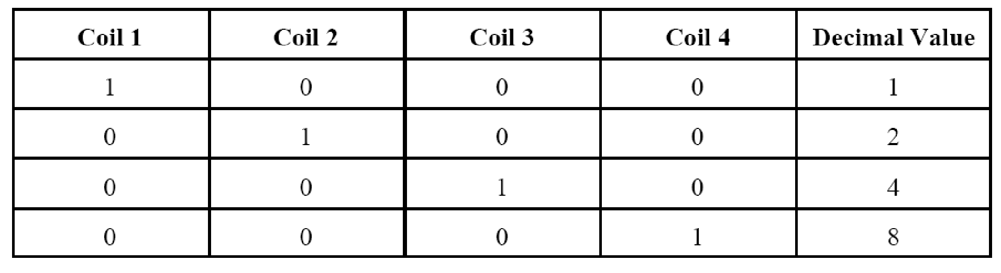

- PROCESS DIAGRAM:
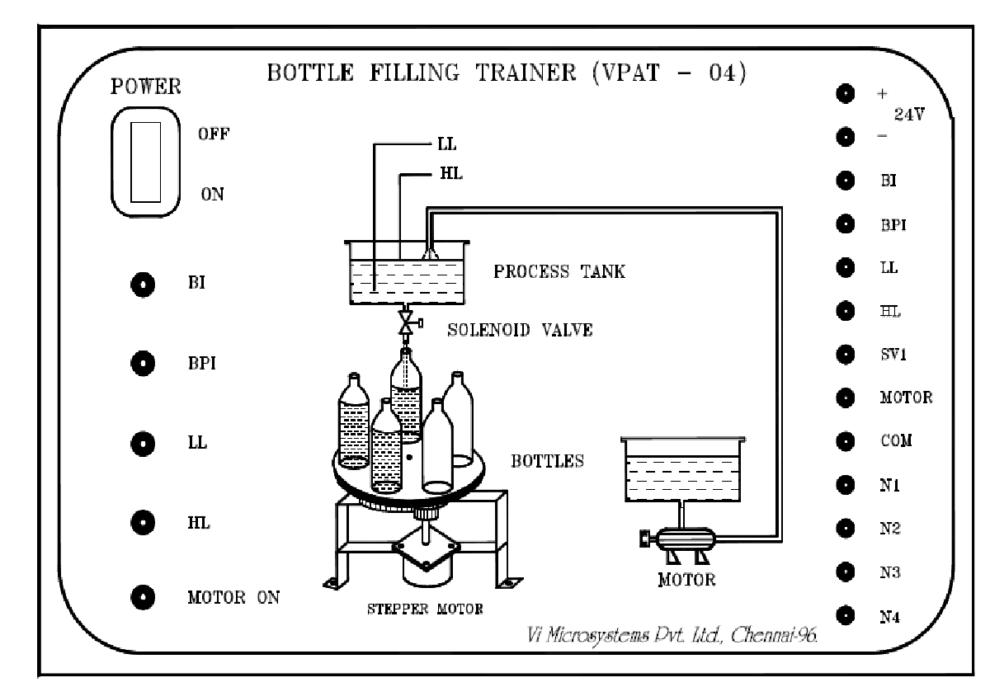

- BLOCK DIAGRAM:
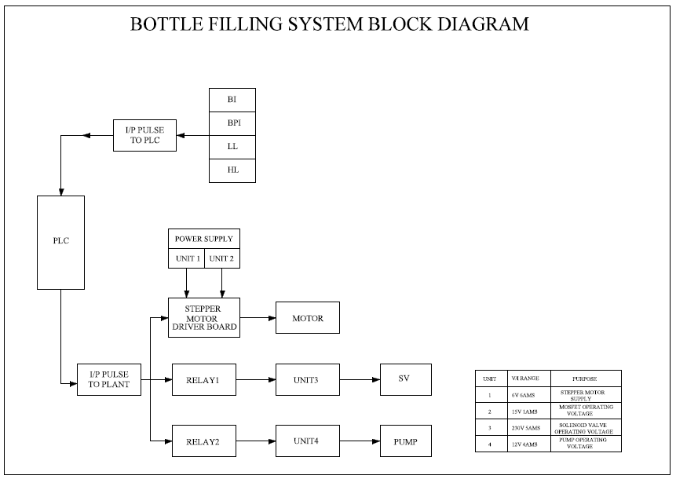

- WIRING DIAGRAM:
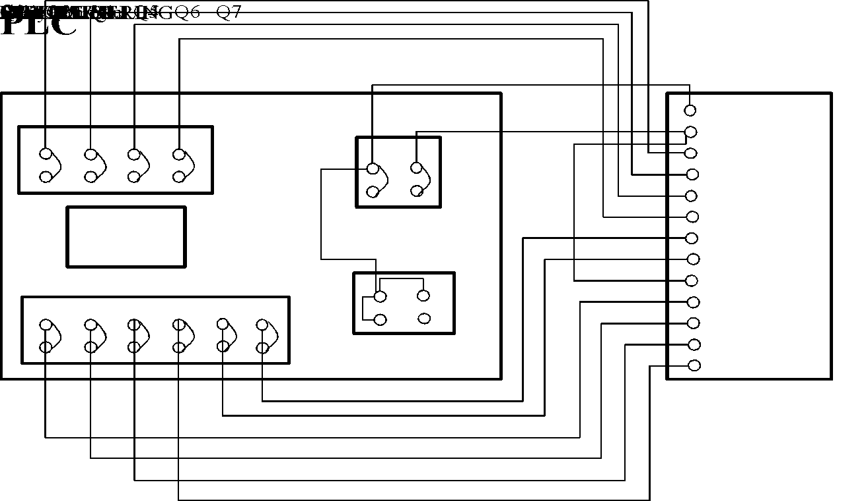

- FLOWCHART:

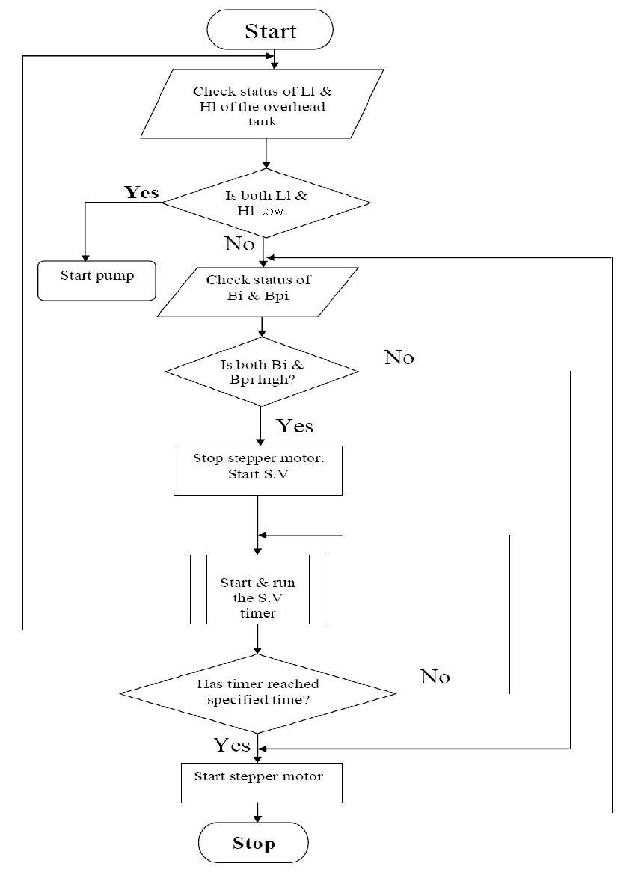

- LADDER DIAGRAM:

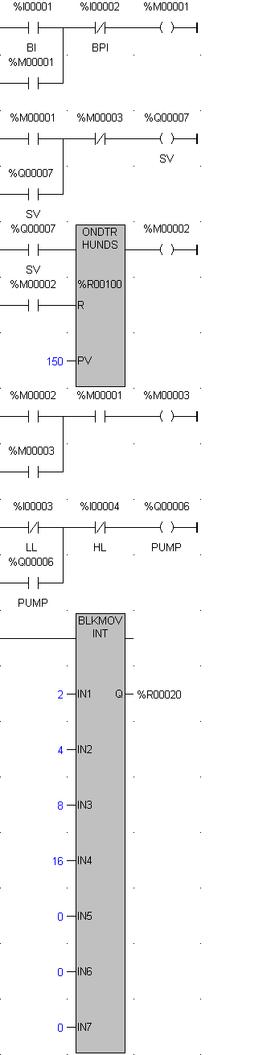
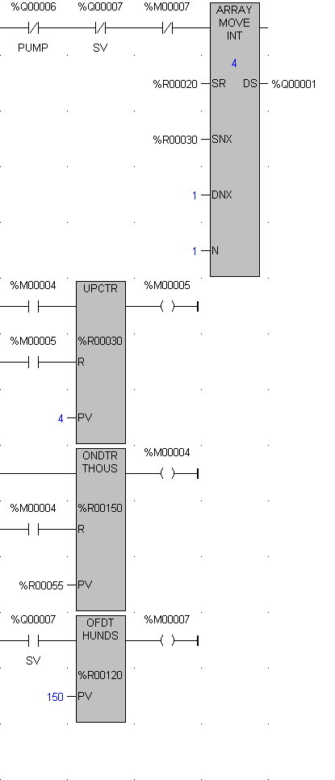



- I/O MAPPING:

- RESULT:
Thus, ladder logic program for Bottle Filling System has been designed and the performance is tested using trainer kit.

